Query Processing and Optimization
Question: Retrieve all appointments on the appointment date 2026-03-10
Query Result
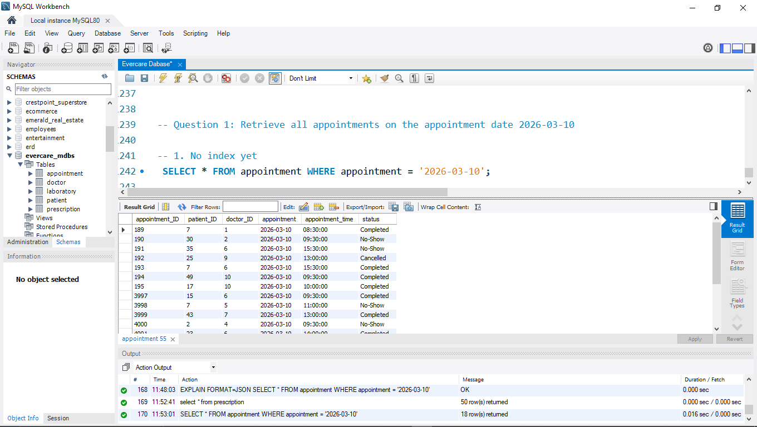
Initial Execution Plan without Indexing
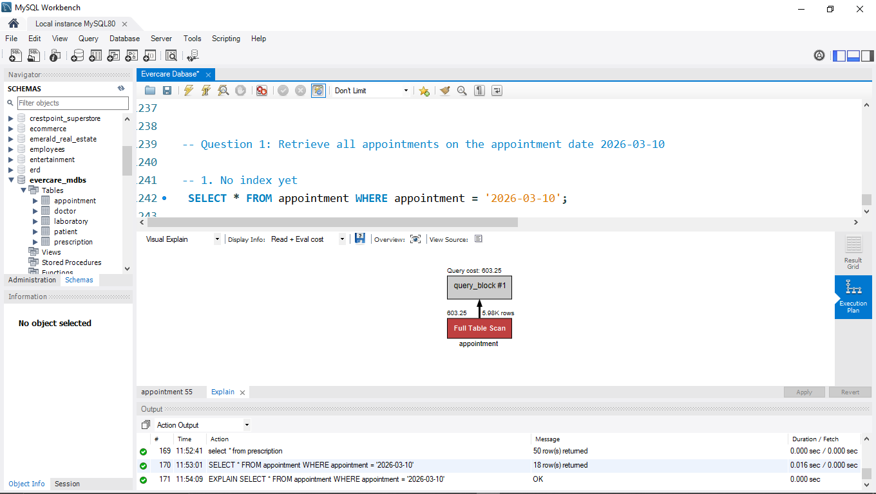

Index Created
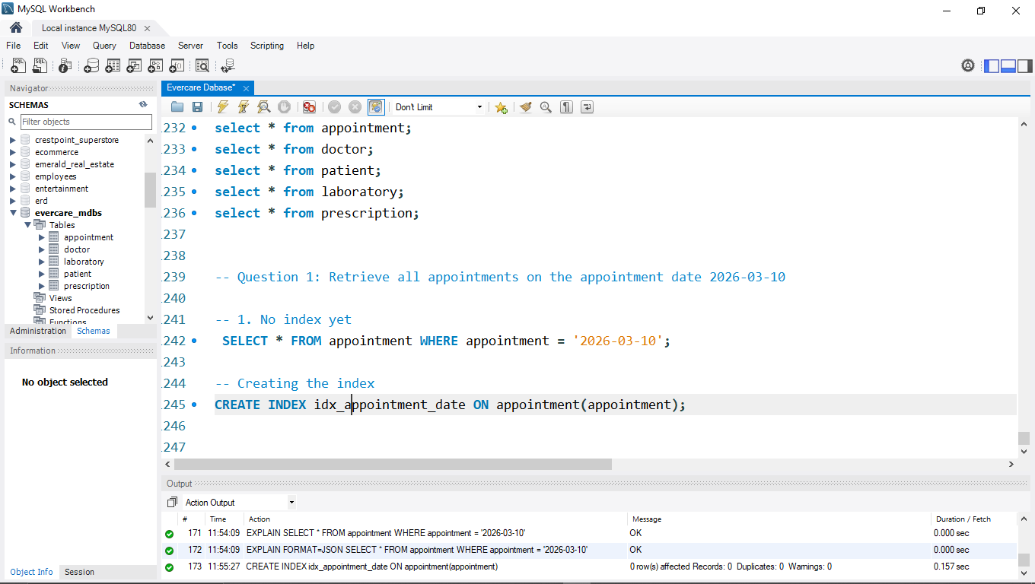

Execution Plan After Indexing
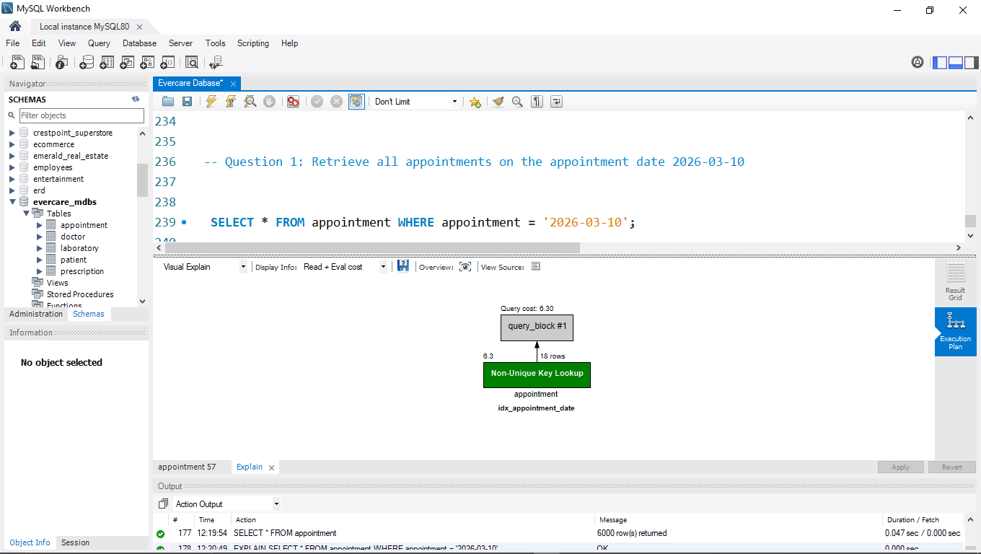

Performance Analysis
With no index on the appointment column, MySQL has no shortcut, so it does a Full Table Scan. It reads every row in the table (Shown as an estimated 5.98K) and checks each one against ‘2026-03-10’. Almost all that work is wasted, because only 18 rows match. The estimated cost is 603.25
When an index is created on the appointment column, MySQL now goes straight to the entries for 2026-03-10 in the index and fetches only those rows. The estimated cost is 6.30, and the estimated rows are 18.
While executing the query without an index, it took about 0.016 seconds to run. However, after indexing, the query only ran for 0.00 seconds. Although the difference may seem trivial, in a scenario where the dataset is very large, there you can notice this actual time difference.

Question 2: Show all records where status is completed
Query Result
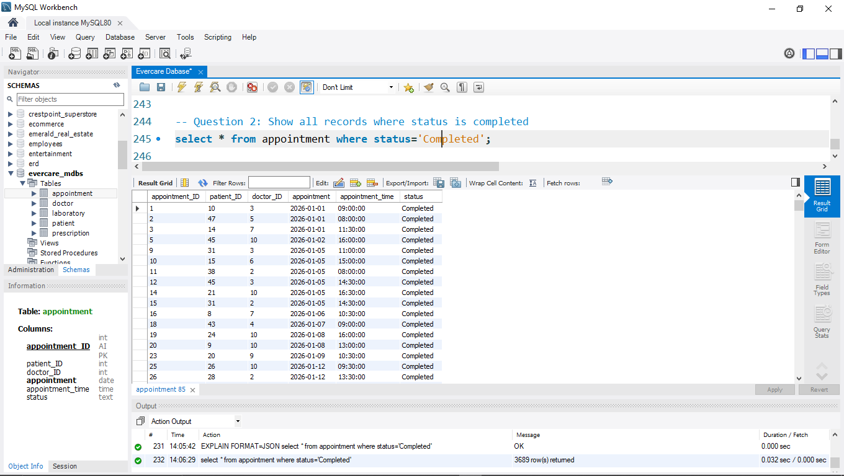
Initial Execution Plan without Indexing
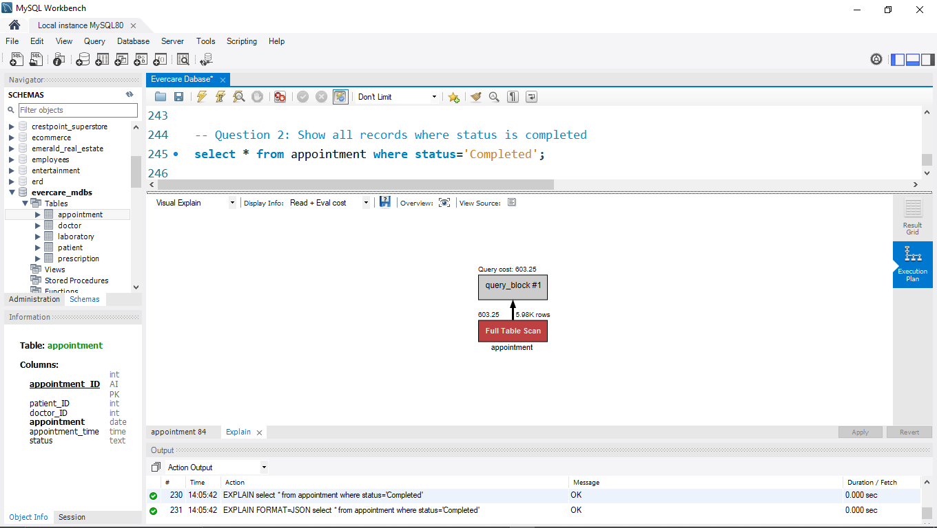
Index Created
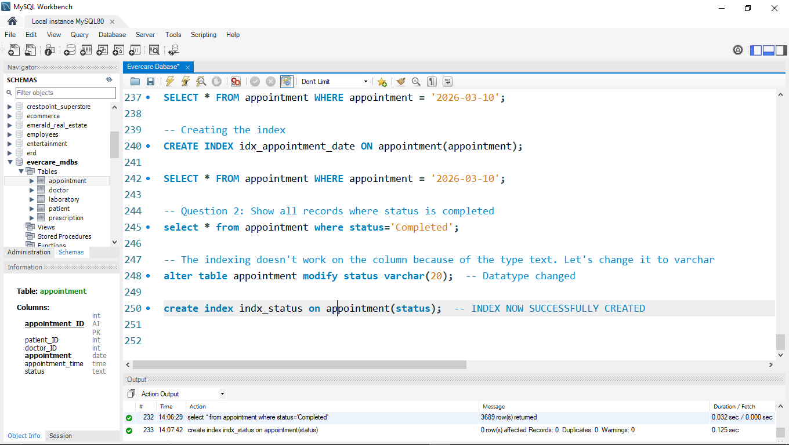

Execution Plan After Indexing
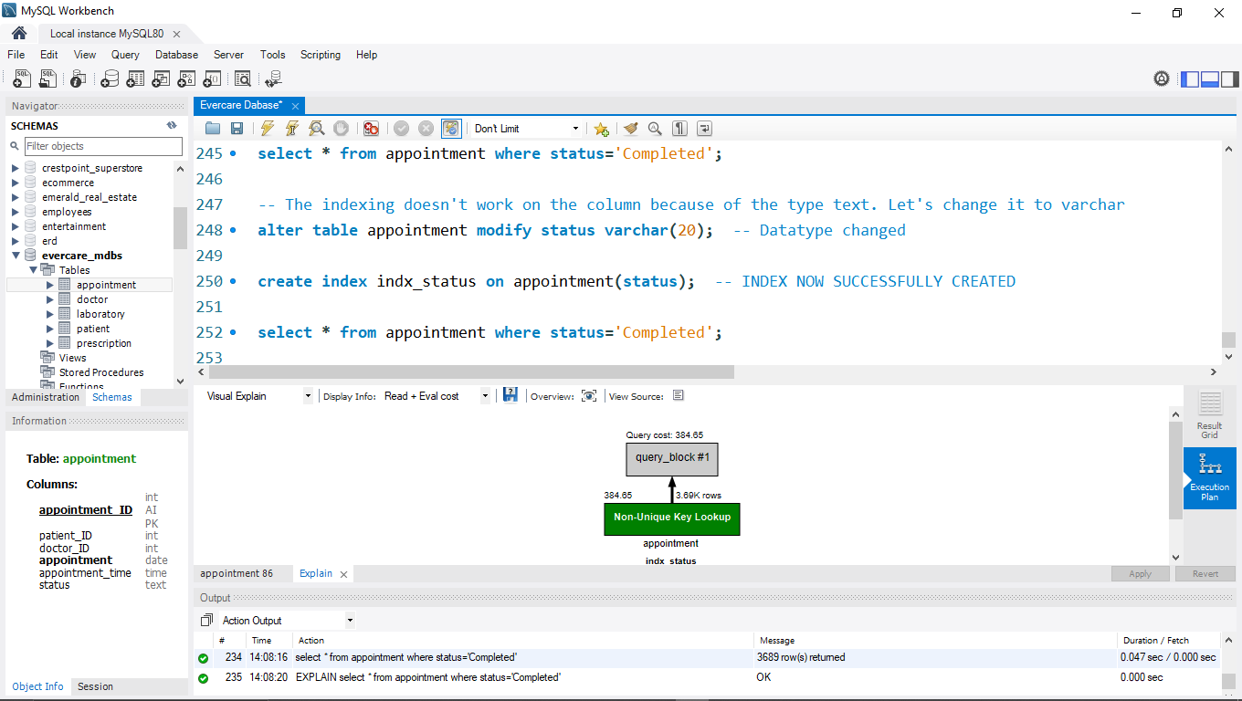

Performance Analysis
From the first image on question 2, MySQL does a full table scan of over 5000 records (5.98k rows) which cost 603.25.
In contrast, after the index was created (0.125 sec), the query search was optimized and as can be seen from the second image, only 3.69k rows were scanned with a query cost of 384.65. Through this, the database uses less time and resources to query data from the database.

